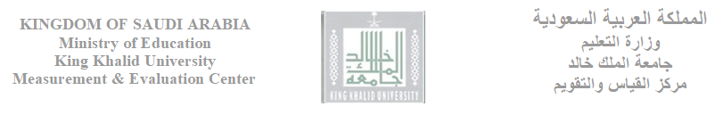

Course Syllabus
First: Course Information
College: | Department:
Academic Semester: | Academic year: H14 /H14
Course Name: | Course code and number:
Number of credit hours: ...... Units (........ theoretical/lecture, ........ practical/lab )
Course requirement in program: [ ] Required (obligatory) [ ] Optional (Elective)
Course type: [ ] University Requirement [ ] College Requirement [ ] Departmental Requirement
Pre-requisite (code and number) (if applicable):

Second: Instructor Information
Instructor's name:
Office phone number:
Mobile (Optional)
Office location and number:
Office hours:
Electronic Site
Email | @kku.edu.sa | @kku.edu.sa | @kku.edu.sa | @kku.edu.sa | @kku.edu.sa

Third: Lecture and lab timetables
Section number | Days | Time | Location (Building/Room)
Section 1
Section 2
Section 3
Section 4
Section 5

Fourth: Course description
Course description as found in the University Catalogue in English

Course description as found in the University Catalogue in Arabic

Fifth: Learning outcomes (Knowledge, Skills, and Cognitive) Teaching Strategies, and Assessment Tools.
Note: The classification of the National Commission for Assessment and Accreditation of Learning Products in the decision can be adopted
Learning Outcomes (Knowledge, Skills, and Cognitive) | Teaching strategies and instructional aids | Assessment Tools

Sixth: Course or Curriculum units, subjects, specific unit's learning outcomes, and time schedule in the academic semester

Week number | Units |  | Learning outcomes for each unit or subject | Readings |  | Activities | Notes (Activities' submission dates & instructions)
 | Unit Number | Unit/Chapter/Subject title |  | Reference | Pages
1
2
3
4
5
6
7
8
9
10
11
12
13
14
15

Seventh: Exams and Assessment Plan
Assessment tools | Date and duration (day/date/ time) | Subject matter covered in the exam | Type of questions | Grades out of 100 | Guidelines and instructions
First exam
Second Exam
Final |  |  |  |  | Clarifying examples:  -Questions are MC  -Number of question =50  -Equations table will be included  -Statistical table will be included
Non-exam assessment | Description of the activity to be performed by the student | Due date | Rubrics to be used | Grades out of 100 | Guidelines and instructions

Eighth: Readings and further References
1 | Main Reference (Textbook) (correct citation in accordance to standards specific to discipline)  From where student can get the textbook?
Extra reading references and citations (books, internet cities, research papers)
2
3
4
5

Ninth: The instructor's policy of dealing with students within the framework of the university laws, regulations, and guidelines (examples and prototypes). Notes: Please see (The student Guideline) at the Registration Deanship's Website: http://dar.kku.edu.sa/sites/dar.kku.edu.sa/files/general_files/files/dalelhaltalp_0.pdf

1 | Participation
2 | Late attendance
2 | Cheating and plagiarism
4 | Late work policy
5 | Exiting during the lecture period

